Software Requirement Specification

Echo Social Media Application For Android

Prepared by:
Varun Kumar
Harmanjot Singh

BTech 2nd Year
Thapar Institute of Engineering and Technology
Table of Contents
Chapter | Topic
1 | Introduction
1.1 | Purpose
1.2 | Document Conventions
1.3 | Intended Audience and Reading Suggestions
1.4 | Product Scope
1.5 | Overview
2 | Overall Description
2.1 | Product Perspective
2.2 | Product Functions
2.3 | User Characteristics
2.4 | Operating Environment
2.5 | Design and Implementation Constraints
2.6 | Assumptions and Dependencies
2.7 | User Stories
3 | Specific Requirements
3.1 | External interface Requirements
3.2 | Detailed Description of Functional Requirements
3.2.1 | Functional Requirements for Login/Register Screen
3.2.2 | Functional Requirements for Home Screen
3.2.3 | Functional requirements for Profile Screen
3.2.4 | Functional requirements for Post Screen
3.2.5 | Functional requirements for Add Post Screen
3.2.6 | Functional requirements for Search Screen
3.3 | Performance requirement
3.4 | Use Case Diagram
3.5 | Activity Diagram
3.6 | Data Flow Diagram
3.7 | Class Diagram
4 | System Features
1. Introduction
1.1 Purpose
The purpose of this SRS document is to provide a detailed overview of our software product E-learning Platform, a web-based E-learning platform. This document describes the project's target audience and its user interface, hardware and software requirements. It defines how our client, team and audience see the product and its functionality.

1.2 Document Conventions
Term | Definition
FRU | Functional Requirement: User Registration and profile Settings.
FRF | Functional Requirement: Friends and suggestions.
FRP | Functional Requirement: Posts
FRC | Functional Requirement: Comment

1.3 Intended Audience and Reading Suggestions
- This document is intended for students trans….

  - Product Scope
E-learning platform aims to develop a safe, user-friendly website that offers essential branch-specific materials. The platform will ensure that user receive accurate and consolidated course materials. In this system the user has direct access to all course materials and can download them.
The software must be able to perform the following operations:

- Authentication:
It must be able to authenticate the username and password of administrator in order to provide security.

- Download:
User has privilege to access and download the course material.

- Update course details
Administrator must be able to update the course details in the database & system must not permit the user to alter the course details.

- Comment:
User can dropdown comments as feedback which will be further acknowledged by the administrator

Initially we plan to design a prototype of the software which will be incremented future based on the feedback evaluation.

1.5 Overview
- The remaining sections of this document provide a general description, including characteristics of the users of this project, the product's hardware, and the functional and data requirements of the product. General description of the project is discussed in section 2 of this document. Section 2 gives the functional requirements, data requirements and constraints and assumptions made while designing the multi-utility system. It also gives the user viewpoint of product use. Section 3 gives the specific requirements of the product. Section 3.0 also discusses the external interface requirements and gives detailed description of functional requirements.

2. Overall Description
2.1 Product Perspective
- E-learner is a E-learning platform that aims to provide user a safe and friendly website that offers essential branch-specific materials.

2.2 Product Functions
The Product should be able to perform the following operations:
- Learning Delivery:
They offer learners profiles with contact data and information about courses, online assignments for learners, and learner performance assessment.

- User-friendly Interface:
The website should be accessible across different devices (desktops, tablets, and mobile phones) with a responsive design to accommodate various learning preferences..

- Interactive Learning Content:
Incorporate multimedia elements such as videos(links), to engage learners and make the content more dynamic.

- Secure Platform:
Ensure the platform adheres to strict security standards to protect user data, personal information, and payment details.

- Scalability:
Build a scalable infrastructure that can accommodate a growing number of users and courses without compromising performance.

2.3 User Characteristics
Users:
Characteristics: who interact with the platform
Roles : primary goal of user is to seek knowledge from course material and can interact through feedback

Administrators:
Characteristics: Administrators are individuals responsible for overseeing the overall operations . They often have decision-making authority, technical expertise, and a deep understanding of the platform's goals and objectives.
Roles: Administrators have the highest level of access and control within E learning website . They are responsible for managing comments and course contents.

2.4 Operating Environment
- Platform Compatibility:
Chat-byte is designed to operate as a web-based application accessible through modern web browsers. This includes popular browsers such as Google Chrome, Mozilla Firefox, Safari, and Microsoft Edge. The platform is optimized for compatibility with the latest versions of these browsers to ensure a seamless user experience across devices and operating systems
• Device Compatibility:
Chat-byte is compatible with a wide range of devices, including desktop computers, laptops, tablets, and smartphones. The platform's responsive design and adaptive layout ensure optimal performance and usability on different screen sizes and resolutions.

2.5 Design and Implementation Constraints
- Adherence to Android platform guidelines and design principles set by Google to ensure consistency and compatibility across devices. Compatibility with various Android versions and screen sizes, including smartphones, tablets, and foldable devices. Compliance with Google Play Store policies and restrictions regarding content, permissions, and app behavior.
- Designing the app architecture and codebase in a modular and scalable manner to accommodate future growth and changes.
- Proper documentation, version control, and coding standards to facilitate collaboration among developers and maintainability of the codebase.
- Integration with external APIs, SDKs, and services for features like authentication, analytics, push notifications, and social sharing.

2.6 Assumptions and Dependencies
- There will be availability of Internet via 3G, 4G, 5G or Wi-Fi.
- The user of the app should be well acquainted with English Language.
- The user should have valid email address to register into the app.
- Center server of the system must be able to handle all the incoming requests.
- The user should have basic knowledge of android.

2.7 User Stories
Sno | Action | Acceptance Criteria
1. | As a user, I want to create a new account, so I can start using the social media app. | User should be able to sign up using email. User must provide an email, name, password, and optional profile information. Upon successful signup show confirmation.
2. | As a user, I want to personalize my profile, so I can show others. | User should be able to upload a profile picture. User must have the option to fill in profile details such as bio, nationality. Profile editing should be intuitive and allow for easy updates.
3. | As a user, I want to post updates and share content with my followers, so I can engage with my network. | User should have a "Compose" button to create new posts.  User must be able to share text, images. Posts should be visible in the user's followers' feeds.
4. | As a user, I want to follow other users and discover new content, so I can stay connected and informed. | User should be able to search for users by username. User must have the option to follow/unfollow other users. Also view profile of user.
5. | As a user, I want to engage with content by bookmarking, commenting, so I can interact with others. | User should see options to bookmark, comment posts in their feed. User must be able to view comments on posts.

3. Specific Requirements:
3.1 External Interface Requirements:
The Following list present the external interface requirements:
- The product requires very limited graphics usage with simple keyboard for taking the user input.
- The product does not require usage of sound. The hardware and operating system.

3.2 Detailed description of functional requirements:
Table shows a template that will be used to describe functional requirements for user.

Purpose | A description of the functional requirements and its reasons.
Inputs | What are the inputs; in what form will they arrive; from what sources can the input come; what are the legal domains of each input
Processing | Describes the outcome rather than the implementation; includes any  validity checks on the data, exact timing of operation (if needed), how  to handle unexpected or abnormal situations
Outputs | The form, shape, destination, and volume of output; output timing;  range of parameters in the output; unit of measure of the output;  process by which output is stored or destroyed; process for handling  error message produced as output.

3.2.1 Functional Requirements for Register/Login Screen
Table shows the functional requirements for Register/Login Screen

Purpose | This Screen provides as an interface for registration or Logging in back into the app.
Inputs | For Registration: email, name, bio, nationality, and password are inputs where email, name and password are required inputs.  For Login: email and password are required inputs.
Processing | On register/login request, the request is sent to Google Firebase for processing and waiting for the response.
Outputs | If the response is success, then user is confirmed and logged in the app.  Else cause of fail(error) is displayed to the user.

3.2.2 Functional Requirements for Home Screen
Table shows the functional requirements for Home Screen

Purpose | This screen is used to display real time posts update from friends, content discovery and social interactions.  It also contains Bottom Navigation which contains all the routes to other screens like search, profile, and new post screen.
Inputs | User Profile data, device interaction such as touch gestures, and taps for navigation across different screens.  Tap on Post to get expanded Post Screen View.
Processing | Get all posts and format in order to display in visually appealing manner.
Outputs | Display of posts, with images from other users and friends.  Options to bookmark and comment on a Post.  Navigate to different screens.

3.2.3 Functional Requirements for Profile Screen
Table shows the functional requirement for Profile Screen

Purpose | The profile screen serves as a centralized location for users to manage their personal information, interact with their posts, friends.
Inputs | Unformatted User instance from User database with name, bio, profile picture, contact info etc.
Processing | Fetching user profile data, including personal information. Processing and formatting the retrieved data for presentation on the profile screen ensuring a visual appealing and user-friendly layout.
Outputs | Displaying user profile data such as name, bio, profile picture, contact details, nationality, etc. in a visually appealing manner.  Content Display and interaction with posts and comments.  Displaying list of followers, following, bookmarks, and posts.

3.2.4 Functional Requirement for Post Screen
Table below show the functional requirement for Post Screen.

Purpose | The purpose of the expanded post view is to provide users with detailed information and interaction options for a specific post. This view allows users to engage with the content more deeply, including reading longer texts, viewing larger images or videos, and interacting with comments and reactions.
Inputs | Text content of the post, including captions or descriptions.  Media content such as images, videos, or links.  Information about the user who created the post, including profile picture, username, and bio.
Processing | Rendering of text, images, videos, and other media elements within the expanded view.  Responsive design to adapt to various screen sizes and orientations. Processing user interactions such as bookmarks, comments, etc.
Outputs | Display of the post's content in an expanded format, allowing users to view details and media elements.  Options to zoom in or out, play videos, or swipe through multiple images.  Interactive elements for bookmarking, commenting, sharing the post.  Navigation options to return to the feed or explore related user profile.

3.2.5 Functional Requirement for Add Post Screen
Table below show the functional requirement for Add Post Screen.

Purpose | The purpose of the "Add Post" screen is to allow users to create and upload new content, such as text, images, or links, to share with their social network.
Inputs | Text input for composing the post caption or message.  Options for uploading images.  Interface for selecting media file from the device's gallery or capturing new photos/videos using the camera.
Processing | Handling the uploading of media files to the server, including image and optimization for faster upload speeds.
Outputs | Displaying the newly created post in the user's feed and profile, visible to the intended audience. Providing options to delete the post after it has been published.

3.2.6 Functional Requirement for Search Screen
Table below show the functional requirement for Search Screen.

Purpose | The primary purpose of the search screen is to allow users to find and connect with existing users within the social media platform. This feature enables users to discover friends, family, colleagues, or other individuals they may know or want to follow.
Inputs | Text input field for users to enter the email of the person they are searching for. Support for partial or full name matching.
Processing | Implementation of an efficient search algorithm to retrieve relevant user profiles based on the provided query.
Outputs | Display of user profiles matching the search query, including profile pictures, usernames, and brief information. Detailed view of individual user profiles upon selection from the search results (Profile Screen for that user).

3.3 Performance Requirement
- The app should load within a reasonable time frame, typically within a few seconds, to ensure users can quickly access their feed and content.
- User interactions such as scrolling, tapping on buttons, and opening posts should result in immediate feedback without noticeable delays.
- The app should handle intermittent network connectivity gracefully.
- Database queries and operations should be optimized for performance to ensure fast retrieval and manipulation of user data.
- Ensure smooth and consistent UI rendering across different devices and screen sizes.
- Provide informative error messages and logging for troubleshooting and debugging purposes.

3.4 Use Case Diagram
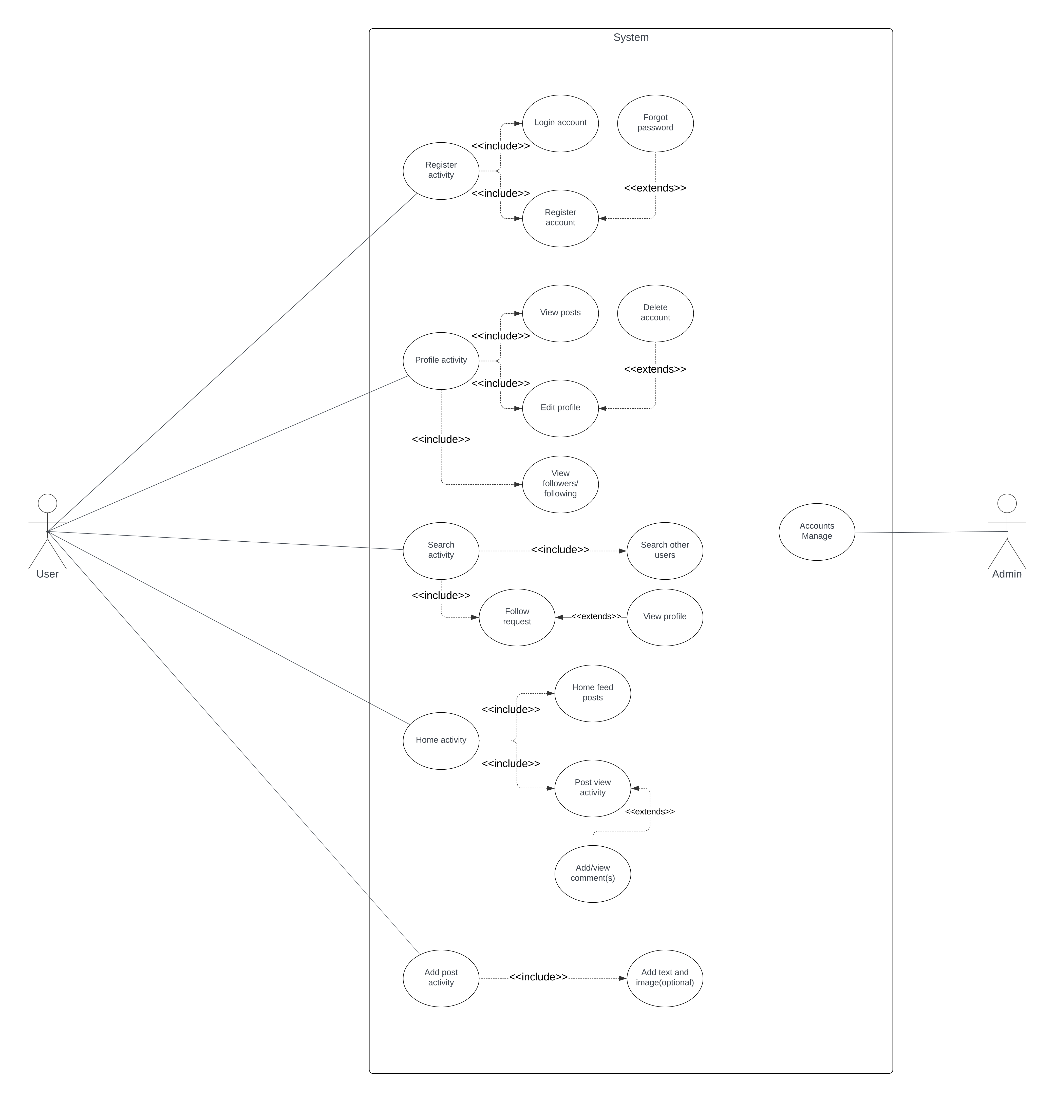

3.5 Activity Diagram
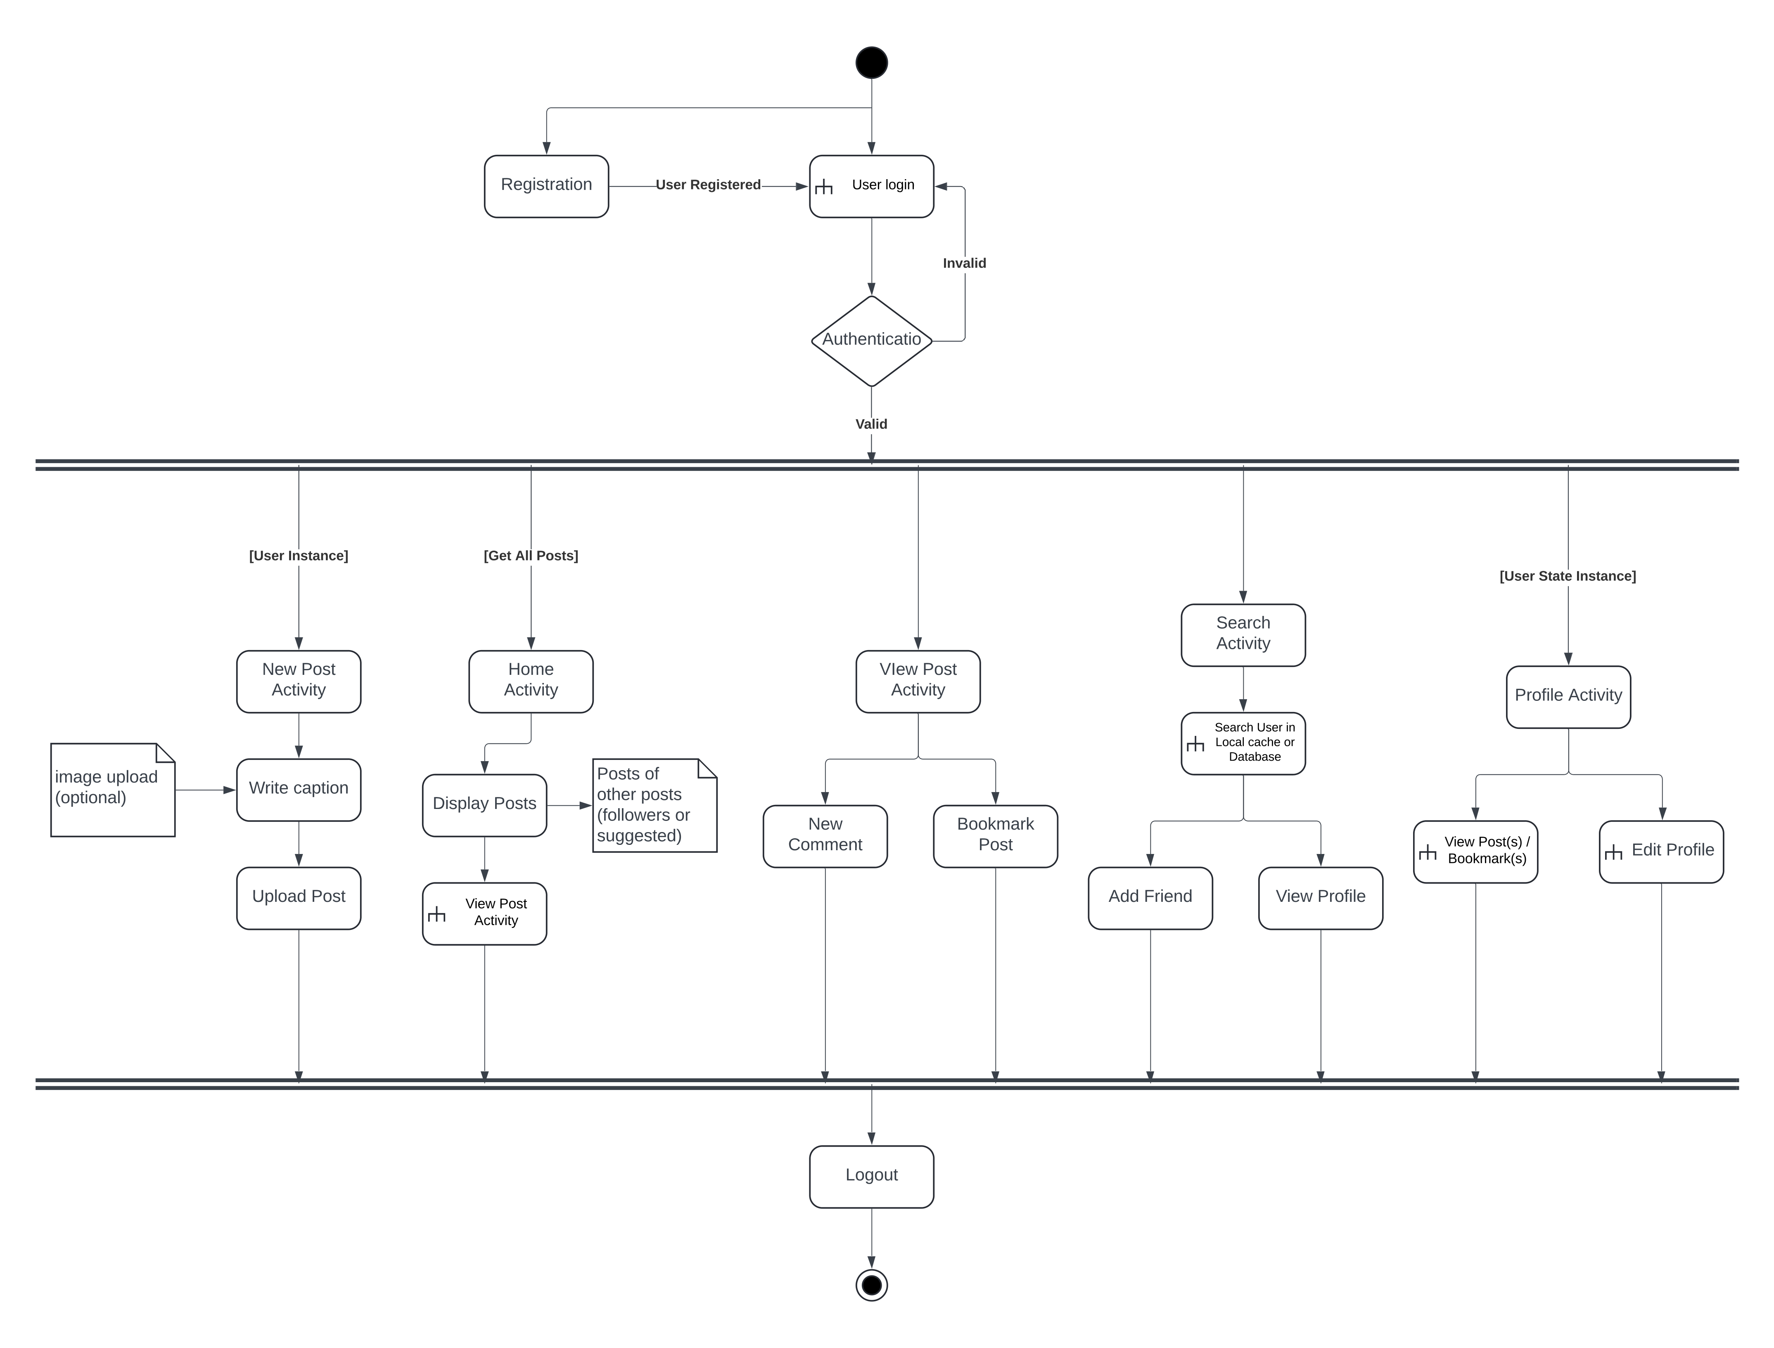

3.6 Data Flow Diagram
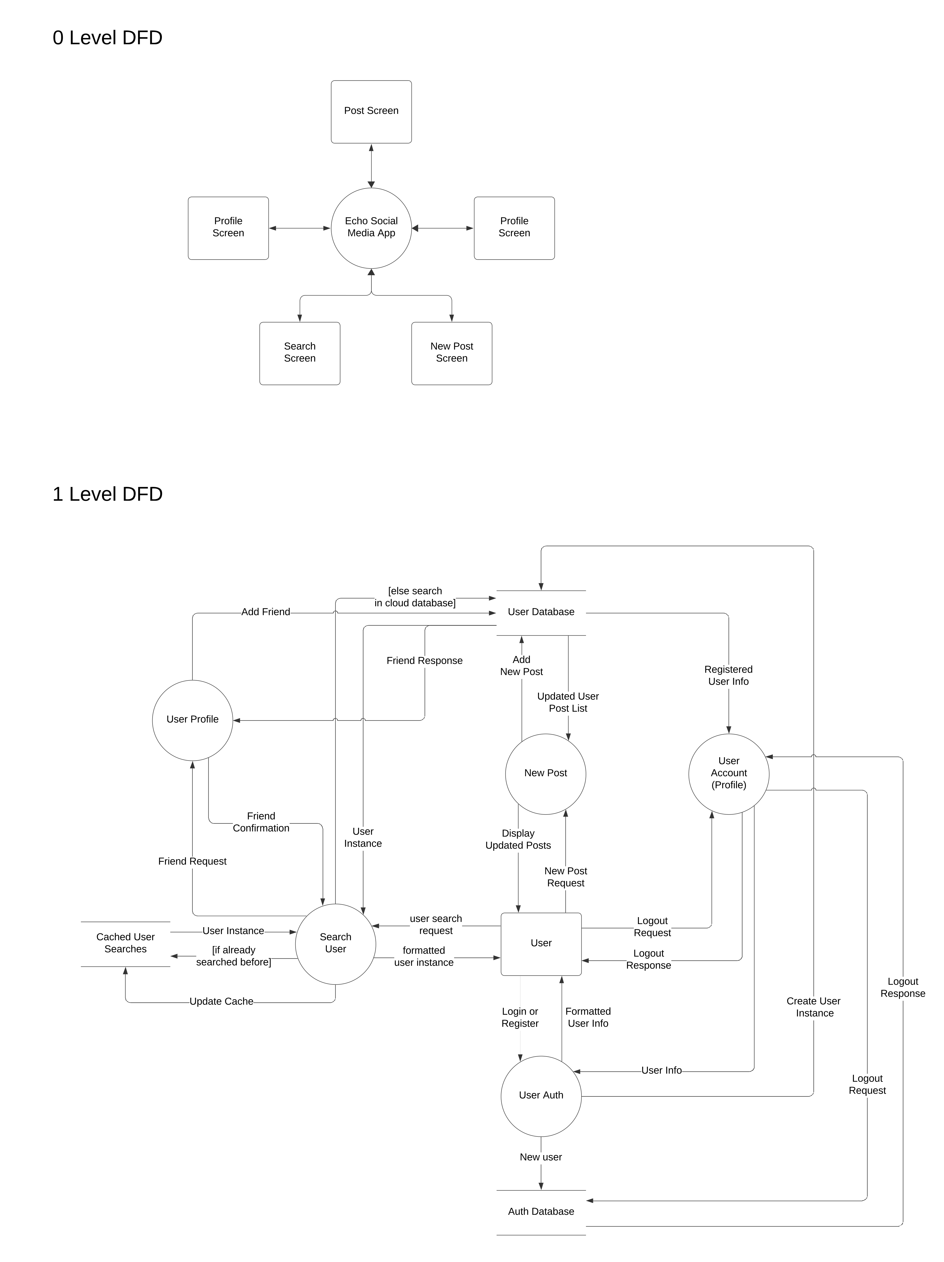

3.7 Class Diagram

4. System Features
4.1 System Feature 1
- Id – FRU1
- Name – User Registration
- Description - User will create an account if there is no existing account associated with email-id. User should enter account details such as name, email-id, bio, nationality etc. and password. Some of these are optional and some of these are required fields and account creation cannot proceed unless these are filled. User is registered after this information is validated. First and last name should not exceed 20 characters each. Password should be at least 6 characters long.
- Dependency - None

4.2 System Feature 2
- Id – FRU2
- Name – Login
- Description - User must be registered to Login. Input will be the email id and password for login. If user clicks on forgot password, then reset password link should be emailed to the user. Input to each field must be validated.
- Dependency - FRU1

4.3 System Feature 3
- ID – FRU3
- Name – Edit/Update Personal Information
- Description – User can change fields such as name, bio, image, nationality, etc. These fields can also remain empty. User must be logged in and his account should be marked as verified to be able to add education. Input to each field must be validated.
- Dependency - FRU2

4.4 System Feature 4
- Id – FRU4
- Name - Upload Profile Picture
- Description - User should be able to upload the profile picture. The size of profile picture should be at least 160px*160px. User may leave this field empty. Profile image should be visible to all.
- Dependency - None

4.5 System Feature 5
- Id – FRU5
- Name - Show Profile
- Description - Any logged in user should be able to see any user profile.
- Dependency - FRU1, FRU2

4.6 System Feature 6
- Id – FRU6
- Name - Delete Account
- Description - User may delete his account permanently depending on his wish. User will be removed from his friends list once deleted. User information will be cleared.
- Dependency - FRU1, FRU2

4.7 System Feature 7
- Id – FRF1
- Name - Add Friend(follower)
- Description - A registered user should be able to send friend requests to other users. User can send friend request to already registered users. User can search his friend among the registered users and then send a friend request to him/her.
- Dependency - FRU1

4.8 System Feature 8
- Id - FRF2
- Name - Unfollow Friend(follower)
- Description – Any registered user should be able to unfollow any of the existing friends
- Dependency - FRU1, FRF1

4.9 System Feature 9
- Id – FRF3
- Name - List Friends
- Description - Whenever the user is on any person's profile page, he should have an option to view currently open user profile's friends on a page. Paging will be implemented to show more followers and load data efficiently.
- Dependency- FRU2, FRU1, FRF1

4.10 System Feature 10
- Id - FRF5
- Name - Search User
- Description - User should be able to search for his/her friends who may be registered on the site. User will put the name of the friend and click search after which the search results will display all the people registered on the site by the searched name.
- Dependency – FRU2

4.11 System Feature 11
- Id - FRP1
- Name – Post
- Description - A registered user can share posts with his friends. The post can only be plain English
- text with maximum 250 characters. User can enter the post in the designated text area and on clicking POST button, should be visible to the user and his friends.
- Dependency- FRU2

4.12 System Feature 12
- Id - FRP2
- Name – Remove Post
- Description - A user can remove a post that has been posted. After deletion, the post should not be visible on the users' or his friends' profiles. Deletion of a post should also remove all the comments associated with that post.
- Dependency - FRU2, FRP1

4.13 System Feature 13
- ID- FRC1
- Name - Comment
- Description -For each post visible to the user he can comment on it to his opinion. The
- comment can contain only text and cannot exceed 500 characters in length. To comment, user can
- see a text area under the post, where he can enter the text.
- Dependency- FRU3, FRP1

4.14 System Feature 14
- Id – FRC2
- Name - Delete Comment
- Description - A user can delete a comment written by him or a comment on his posts. For deleting a post that he is authorized to delete, a user can see a delete link near the comment.
- Dependency- FRU2, FRC1

